Name: Daniells Edwards

andrewID: Daniells

Project Proposal

***Project Description:***

As of right now the name of my project is “Beast Run”. The game will be a side scrolling game that transitions into fighting stages. The game will be single player and multiplayer. There are 3 different bosses to beat with the final boss being the third one. As the player transitions from one stage to the next the background will darker. Score is based on obstacles avoided, monsters killed, the number of lives left at the end and the difficulty level.

***Competitive Analysis:***

What I have noticed from seeing similar projects is that they are single player without the option to play with a friend. My game will differ from these since I will incorporate a multiplayer mode with two options. When the player chooses to play in multiplayer mode they can choose between playing competitive against each other or collaboratively. Aside from this my game will also have a leaderboard screen that will display the top 10 scores. My game will be similar to other games while transitioning to the battle stages in the way that side scrolling games are. Once in the battle stage my game will be similar to fighting games in the way that the character will interact with enemies. It will differ from them since there will be power ups and special moves that the player will be able to use once the energy bar is completely filled.

***Structural Plan:***

Graphics: The graphics will be taken from google images with a transparent background so that they don’t overlap with the rest of the graphics. The graphics for the character and the enemies will be represented by a class and the rest will be inserted in dictionaries and lists.

Functions: I will have functions for drawing each aspect of the screen, ex.(one for the character, the background, the platform, and for the enemies). I will then have functions for the interaction between the character and the enemies and the character and the obstacles.

Objects: Besides the classes for the modes and the screens I will use classes for the obstacles, the characters, the enemies and the final bosses. The enemies and the final boss will be subclasses of the class enemies.

***Algorithmic Plan:***

I think that the trickiest plan for the game will be computing how the enemies will be moving and attacking corresponding to their location to the character and the character’s status. In order to tackle this part. I will write down functions for each situation that the enemy might find themselves in. If I am able to code each situation that the enemies will find themselves in, then the enemies will know how to react to it.

***Timeline Plan:***

I expect to have the single player mode done with its features by Monday 25th. I will be trying to implement the multiplayer modes by Friday 29th. After implementing the multiplayer mode and reaching MVP I will try to see if I could incorporate sockets into the game and make the multiplayer mode be playable through different computers.

***TP2 Update:***

I have decided to change the location of the health and special bar in the User Interface.

***TP3 Update:***

I wasn’t able to finish writing the multiplayer mode because of several problems that were arising as I was working on it and the shortage of time. I also had to change the multiple stages that the game was supposed to have into the different difficulties.

***Version Control Plan:***

I will be back up my code using google drive.

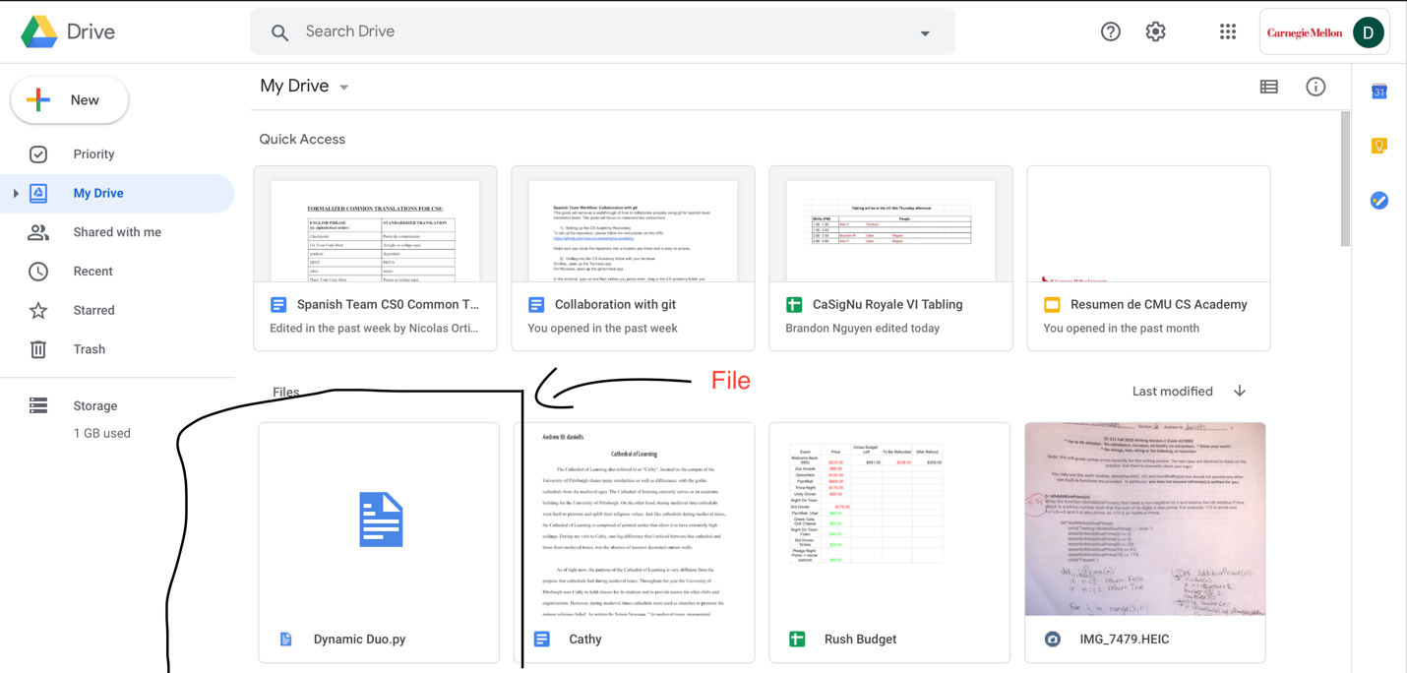

***Module List:***

This is a list of the modules that I will be using in my project

1. Tkinter
2. Random
3. Math
4. Copy
5. Time
6. Pygame.mixer
7. Pillow